Q: CONSTRUCTION AND WORKING OF ULTRA SMALL ASYMMETRIC SUPERCAPACITOR
ANS:-Supercapacitor is an electrochemical energy storage device that stores energy through electrostatic double layer capacitance(EDLC) and electrochemical psuedocapacitance. Exihibiting high power density
Construction:
- Anode : carbon based nanomaterials like graphene
- Cathode: Transition metal oxide (Mn02) with polytetrafluroethylene and n-methyl pyrlodine
- Electrolyte and seperator: Flexible PVA gel membrane treated with aqueous H2SO4 acts both electrolyte and separator (PVA/H2SO4 gel membrane)

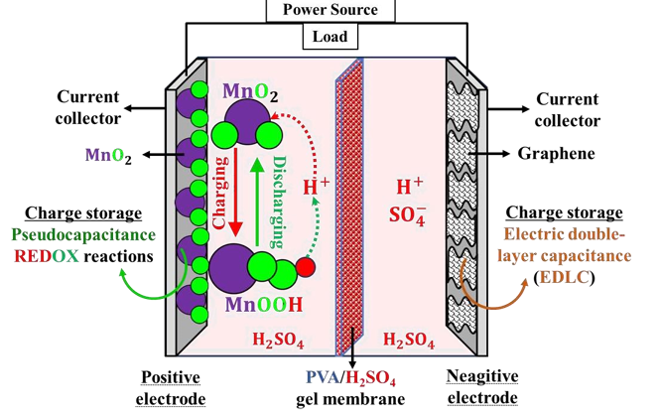Working:
- During the charging and discharging process, the MnO2 positive electrode exhibits pseudocapacitance, storing energy through fast and reversible REDOX reactions.
- MnO2 undergoes a reversible transformation from its +4 oxidation state (MnO2) to +3 oxidation state (MnOOH) in the presence of an acidic electrolyte.
- M𝐧𝐎𝟐 + 𝐇+ + 𝐞− ⇌ 𝐌𝐧𝐎𝐎𝐇
- Meanwhile, the graphene negative electrode exhibits electric double-layer capacitance (EDLC) by adsorbing ions at its surface without undergoing any chemical change. The PVA/ H2SO4 gel membrane serves as a solid-state ionic conductor, enabling the transport of protons (H⁺) between the electrodes to maintain charge balance.
CONSTRUCTION AND WORKING OF SOLID OXIDE FULE CELL

- Cathode: Lanthanum strontium Maganite
- Anode: Nickel and Yttria stabilised Zirconia
- Electrolyte:Yttria stabilized Zttria stabilized Zirconia

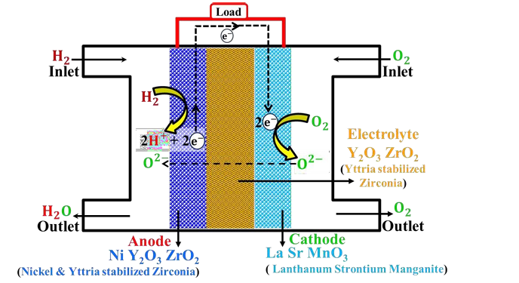

Working:

- In Solid Oxide Fuel Cell (SOFC), ceramic components get activated at very high temperatures (~1000°C).
- Hydrogen (H2) fuel and oxygen (O2) as an oxidant are continuously fed into the inlets of the anode and cathode, respectively.
- At the anode, H2 undergoes oxidation, releasing H+ ions and e−.
- The e− flow through an external circuit, generating electricity, and enter the cathodic compartment.
- At the cathode, O2 picks up the e− and gets reduced to oxygen anions (O2−).
- The O2− anions then migrate through the solid oxide electrolyte to the anode, where they combine with H+ ions to produce water.
- Electrode reactions:
Reaction at anode 𝐇𝟐 → 𝟐𝐇+ + 𝟐𝐞− 2𝐇+ + 𝐎𝟐− → 𝐇𝟐𝐎
- Reaction at cathode 𝐎𝟐+ 2𝐞− → 𝐎𝟐−
- Overall reaction 𝐇𝟐 + ½ O2 → 𝐇𝟐𝐎

